Faz Restaurants

1. – SPANAKOPITA - Spinach, feta and ricotta stuffed phyllo dough. $9.95 – calories 228 (vegetarian)

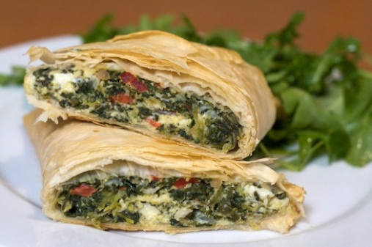

1. Rolled Beef Kabob - Delicately seasoned ground beef. $12.95 – Calories 176 (gluten-free)

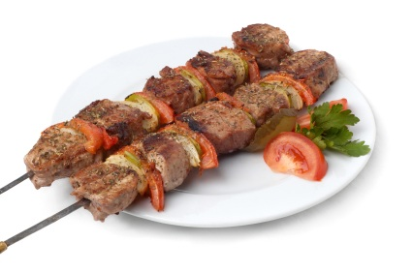

1. Chicken Linguine - With mushrooms, garlic, sun-dried tomatoes in basil, cream sauce. $14.95 – Calories 280 (meat)

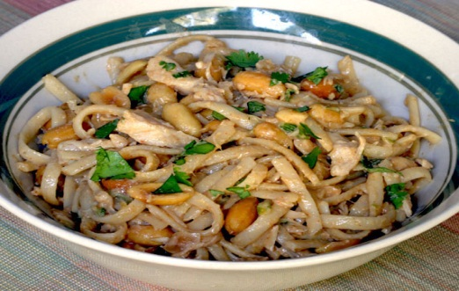

1. Grilled Avocado and shrimp – Grilled half avocado filled with chipotle aioli with grilled shrimp, organic baby greens and chili lime vinaigrette. $15.95 – Calories 470

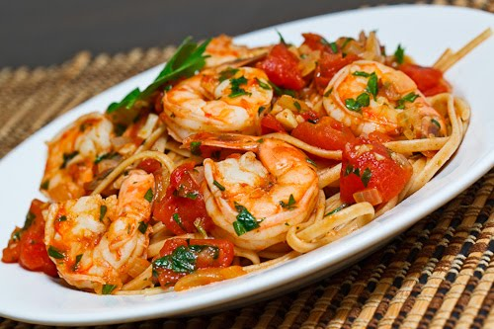

Pad Thai

1. Pad Thai - Pan fried rice stick noodles, egg, tofu, bean sprouts and green onions. $10.95 – Calories 430

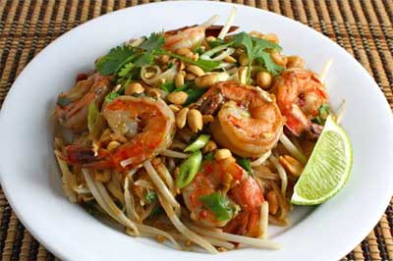

1. Spicy Spaghetti - Pan fried flat spaghetti or flat rice noodles with tomatoes, basil and Thai sauce.. $10.95 – calories 136 (meat)

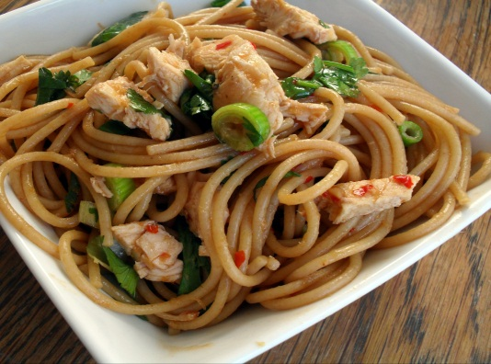

1. Yellow Curry fried rice - Fried rice, egg, tomatoes, onions, carrot & yellow curry. $11.95 –calories 390 (Gluten-free)

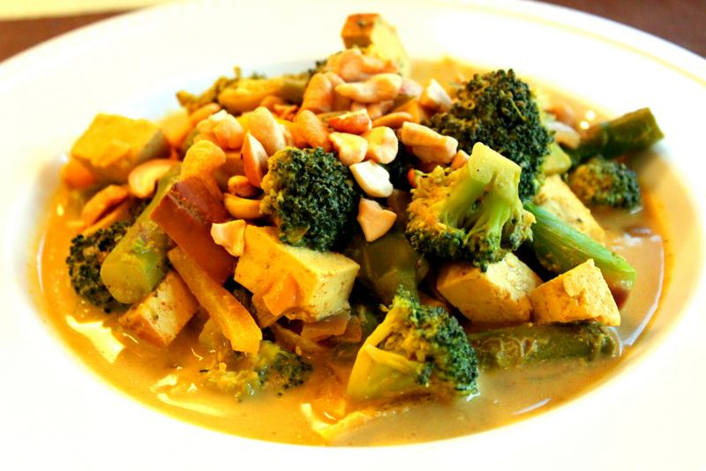

1. Green Curry - Coconut milk, eggplant, bell pepper and basil. $11.95 Calories 375 (vegetarian)

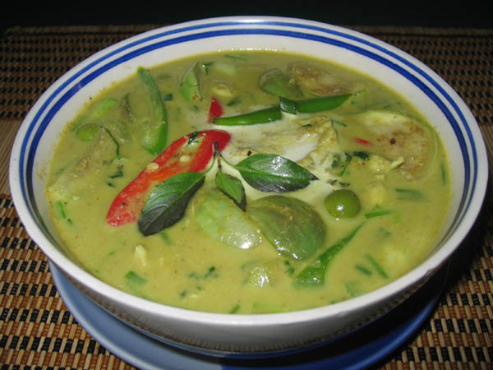

1. Chirashi Sushi - Chef's Special Selection on Rice $13.95 – calories 511 (Gluten-free)

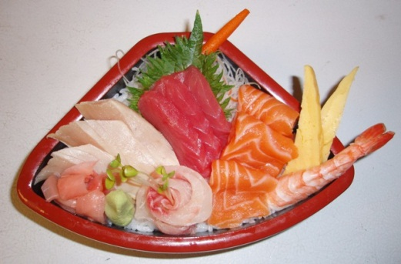

1. Maguro Donburi Sushi - Fresh Fillets of Tuna on Rice $12.95 – calories 400

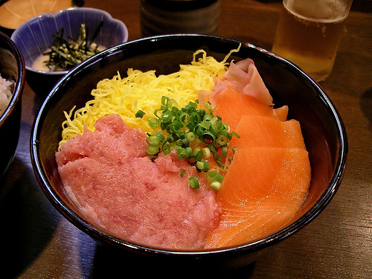

1. YAKITORI - Skewered Broiled Chicken $10.95 – Calories 360 (meat)

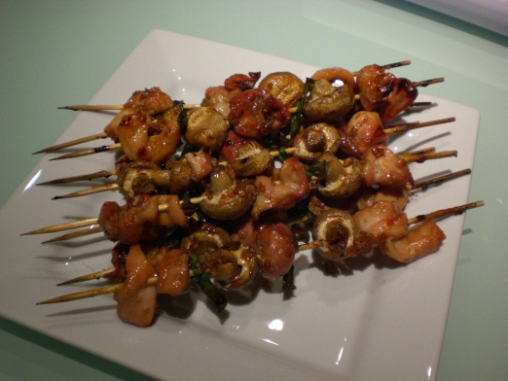

1. AGEDASHI TOFU - Fried Tofu $8.95 – Calories – 210 (vegetarian)

